**Project**

Power Supply with 220V input and (±5, ±15, ±1.25:15)V output

**Done By**

Ammar Alrefaey

Abdelaziz Ammar

Ahmed Wahid

Emad Elseedy

Eslam Negm

Omar Elsobkey

Omar Basala

Ramadan Saber

Samuel Maged

Mohamed Nagy

**Components**

|  |  |  |  |
| --- | --- | --- | --- |
| Name in PCB | Name to buy | Description | Link |
| IN | 3pins Terminal Block |  | http://magicduino.com/ProDetails.aspx?ID=1323 |
| OUT | 12pins Terminal Block |  | https://ram-e-shop.com/product/rc12-12pin-connected/ |
| B2 | 2W10G | Rectifying bridge | http://magicduino.com/ProDetails.aspx?ID=1639 |
| D1:D6 | 1N4007 | Diode | http://magicduino.com/ProDetails.aspx?ID=1611 |
| C1:C8 | Electrolyte Capacitors 1000uF/50V |  | http://magicduino.com/ProDetails.aspx?ID=2126 |
| C9, C10 | Electrolyte Capacitors 10uF/50V |  | http://magicduino.com/ProDetails.aspx?ID=2049 |
| C11, C13, C15, C17 | Ceramic Capacitors 100nF |  | http://magicduino.com/ProDetails.aspx?ID=6733 |
| C12, C14, C16, C18 | Ceramic Capacitors 10nF |  | http://magicduino.com/ProDetails.aspx?ID=1974 |
| R1, R3 | 270 Ohm Resistor |  | http://magicduino.com/ProDetails.aspx?ID=2233 |
| R2, R4 | 10K Ohm Variable Resistor |  | http://magicduino.com/ProDetails.aspx?ID=4054 |
| IC1 | LM317 | 3-terminal positive adjustable voltage regulator | http://magicduino.com/ProDetails.aspx?ID=520 |
| IC2 | LM337 | 3-terminal negative adjustable voltage regulator | http://magicduino.com/ProDetails.aspx?ID=528 |
| IC3 | LM7815 | 3-terminal +15 voltage regulator | http://magicduino.com/ProDetails.aspx?ID=1058 |
| IC4 | LM7805 | 3-terminal +5 voltage regulator | http://magicduino.com/ProDetails.aspx?ID=1046 |
| IC5 | LM7915 | 3-terminal -15 voltage regulator | http://magicduino.com/ProDetails.aspx?ID=1059 |
| IC6 | LM7905 | 3-terminal -5 voltage regulator | http://magicduino.com/ProDetails.aspx?ID=1051 |
|  | Transformer  18-0-18 | 220VAC to 18VAC | http://magicduino.com/ProDetails.aspx?ID=5527 |

**Circuit**

1. 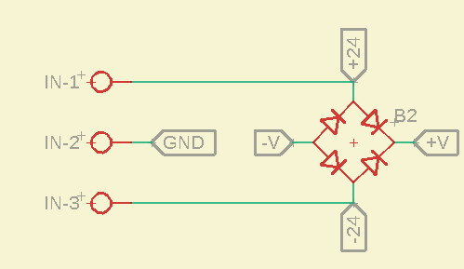**Input**

* there is a transformer that will reduce the 220VAC into 18VAC to deal with it more easily and that’s safer.
* The transformer also separate the noise of the AC source from the rest of the circuit so it’s a better choice than the transformerless power supply
* The bridge is 2W10G constructed from 4 diodes that work as a rectifier to make the current with one direction so it becomes more like DC

1. 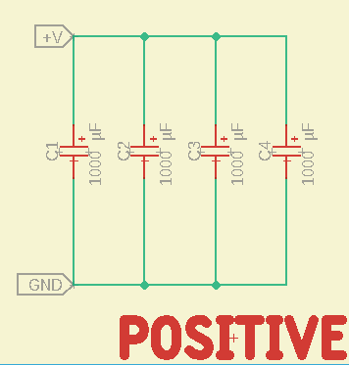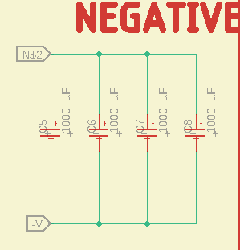**Filter**

* to transform the AC into DC the first step was to make it of one direction and the second step is to have constant value and that’s achieved by using these capacitors as it charges when the current is, in particular, direction and when that direction changes or the current starts to decrease, then the capacitor dischargers so now we have almost constant voltage with some ripple.
* How to choose the value of the capacitor:

C = I / 2.F.Vpp

I is the load current

C is the capacitance

F is the source frequency

Vpp, the minimum ripple (the peak to peak voltage after smoothing) that may be allowable or OK for the user, because practically it's never feasible to make this zero, as that would demand an unworkable, non-viable monstrous capacitor value, probably not feasible for anybody to implement.

For further info: <https://www.homemade-circuits.com/calculating-filter-capacitor-for/>

1. **Voltage Regulation and Output**

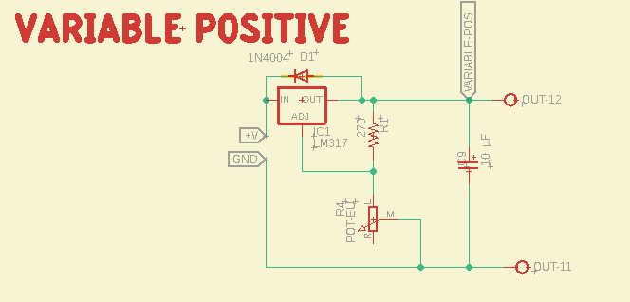

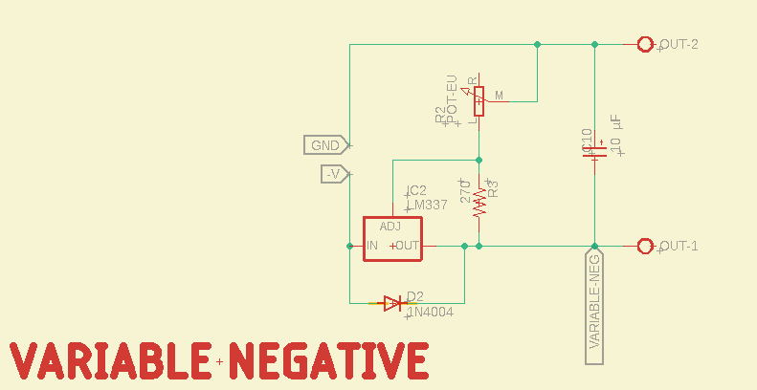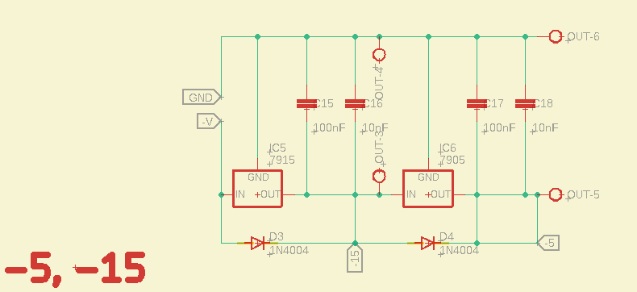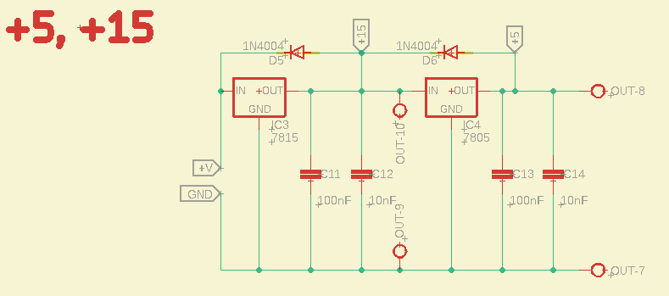

* Voltage regulator is an IC (Integrated Circuit) that decreases the voltage into certain value and the voltage difference between input and output is lost as heat
* Voltage regulators are connected in series (7805, 7815) so that the output of the 7815 (15V) is the input of 7805 which means the input is in the acceptable range that won't break the v-reg
* 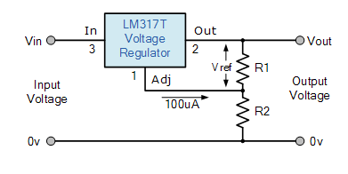The adjustable output v-reg: by using the ratio of two resistances, one of a fixed value and the other variable (or both fixed), we can set the output voltage to the desired level with a corresponding input voltage being anywhere between 3 and 40 volts

Vout = 1.25(1+R1/R2)

* The freewheel diode is to protect the voltage regulator from the reverse current which may occur due to sudden disconnection of the load
* The capacitors (C11:C18) are smoothing capacitors to eliminate any remaining noise or ripple from the original wave or occurred in the IC and their values are due to the datasheet of the voltage regulator

**Simulation (using multisem)**

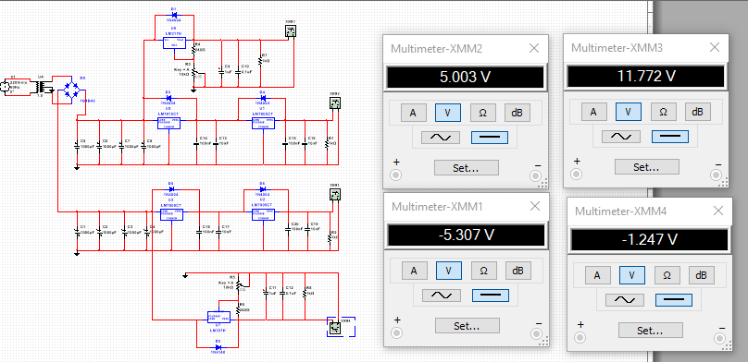

**PCB (using eagle)**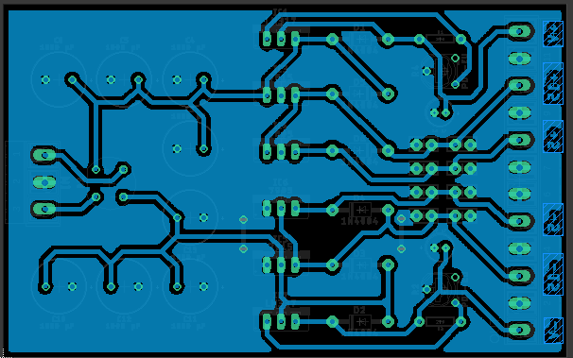

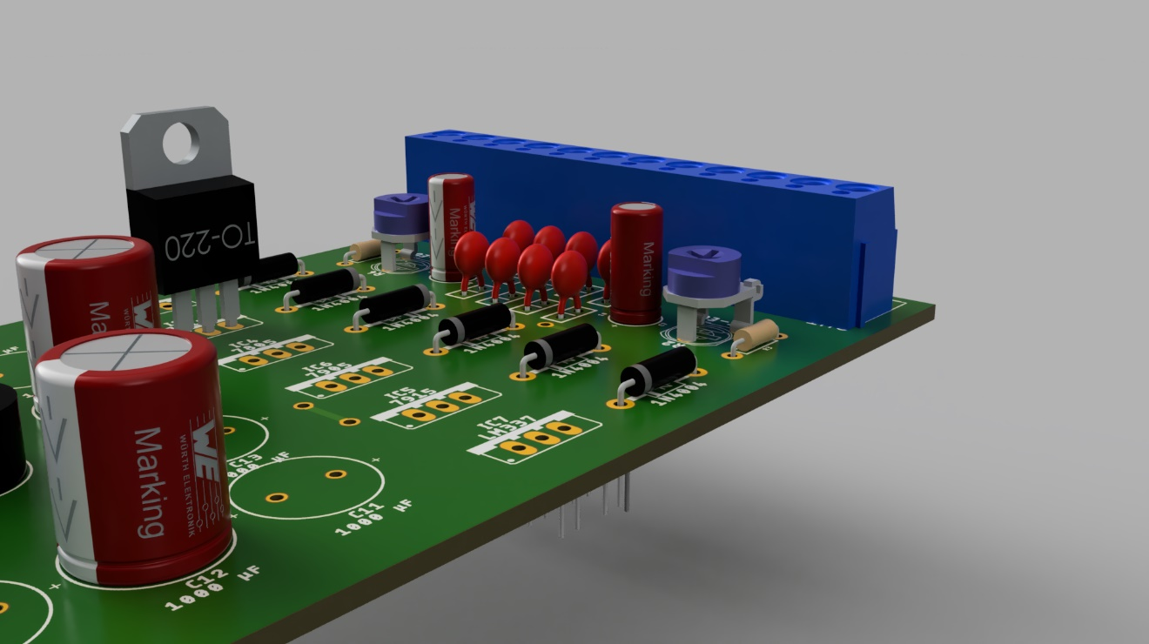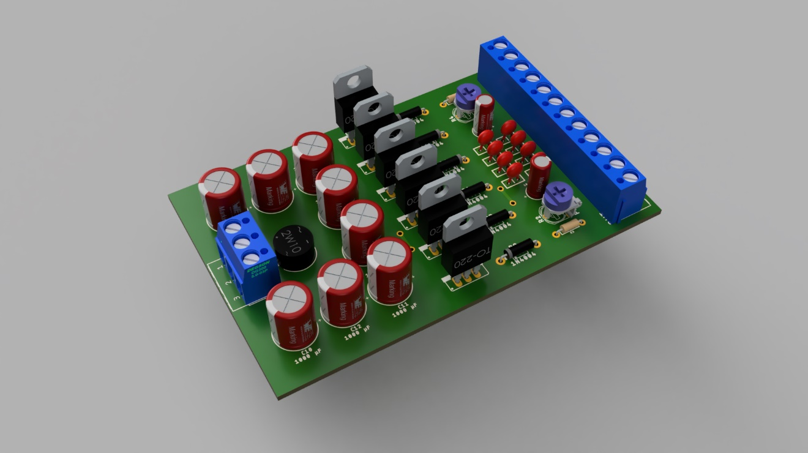**3D Modeling (using Fusion360)**